www.mm4x4.com.au

Mitsubishi Triton MQ

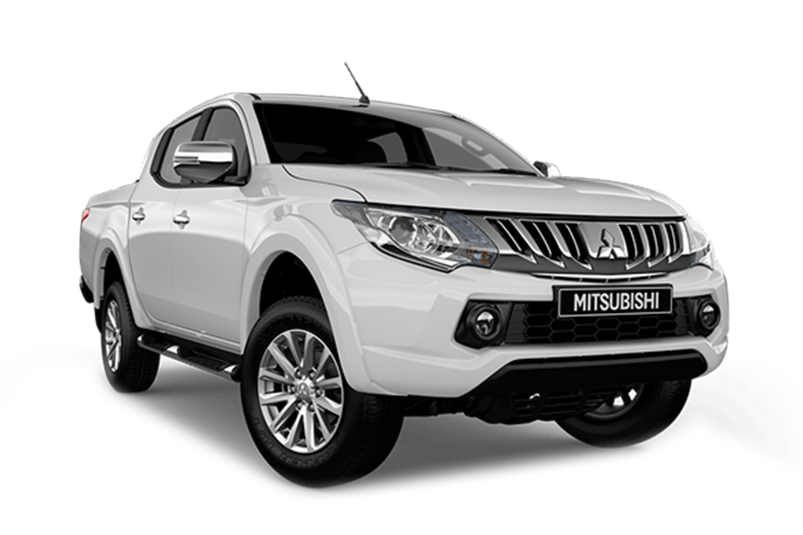
(2016-2018)

Operating Instructions

Rev A: 28 Aug 2020
Watch our installation and operation videos
on the MM 4X4 Channel
OWNERS COPY – Save these instructions for future reference

Thanks for purchasing lockup-mate; a fantastic product to protect the transmission from over-heating, and to improve fuel economy.

OPERATING MANUAL CONTENTS

lockup-mate Features 4
Understanding how lockup-mate works 7
4LLC Low Range Operation 8
PROCEDURE: Entering 4LLc (Low Range 4WD) 8
lockup-mate SPORT mode (low range) 9
Driving Tips 10
DRIVE mode 10
SPORT Mode (a Hybrid DRIVE/SPORT mode) 10
Use the Accelerator Pedal 10
Cold Start 10
Excessive Slip Alert 11
Transmission 1st gear 11
Improved Engine Braking 11
Monitoring the Transmission Oil temperature 11
SafeLock™ - Clutch Protection Technology 11
Operating Recommendations 12
LED/Switch 14
LED Status Summary 14
LED/Switch Commands (while driving) 15
lockup-mate Configuration Parameters 18
Warranty Policy 19

LOCKUP-MATE FEATURES
Feature |  | Benefit
Improved fuel economy |  | The unit will pay for itself in the long run
Significantly reduces automatic transmission heat build-up |  | Prolongs the life of the transmission oil and help to avoid over-heating related transmission damage
Improved engine braking |  | Reduced use of brakes on hill descents
Adjustable lockup sensitivity |  | Can be shifted up and down to tailor to your liking for vehicle modifications.
Fully automatic operation at all speeds and gears; in SPORT and DRIVE modes, 4H and 4L |  | Easy to use  Automatically adjusts for high and low range 4WD
SafeLock™ - Clutch Protection Technology  Lockup engagement uses the same low slip criteria as factory ECU |  | Protect the clutch from excessive wear for long life and reliability
PWM control of the Torque Converter Clutch (TCC) solenoid |  | Mimics the factory control for smooth TCC lockup and confidence
Doesn’t modify the factory ECU firmware |  | No re-maps or error code deletes of the ECU are required
Advanced Digital micro-processor using CANBus interface to ECUs |  | Digital interface to the vehicle computers to provide advanced lockup control and features
Simpler installation with comprehensive installation instructions |  | DIY saves money, or reduces cost if installed by an auto-electrician

Feature |  | Benefit
Compatible with OBD2 devices |  | Compatible with your existing UltraGauge, ScanGauge, GPS HUD, etc
1st gear lockup support |  | Supports transmissions that have undergone a valve body upgrade to enable torque converter lockup in 1st gear
Firmware upgrades |  | Access to future product improvements and new features. Control unit needs to be returned to MM4X4 for firmware updates
lockup-mate Operation
Lockup controller uses speed, RPM, accelerator pedal position, 4WD mode, transmission mode (SPORT or DRIVE), headlight status, temperature, ECU lockup-status, slip, current gear and more |  | Complex logic to ensure the TCC is locked up whenever possible and protect the clutch from excessive wear, and to avoid engine trouble codes
CANBus interface is used to obtain information from the vehicle’s internal digital network, via connection to the existing OBD2 port |  | Precise, reliable and accurate digital information  Simpler installation – no cutting of wires to obtain vehicle information  Immunity to electrical noise
Works when transmission is in either SPORT or DRIVE mode |  | Optimum benefits are obtained in SPORT mode – you shift gears to maximise lockup time.  Keeping the blue LED light on keeps the transmission cool and saves fuel!
Can be enabled or disabled using the LED/Switch |  | Can be easily switched off when desired  Remembers the setting between engine starts
LED status of locked |  | LED is on when TCC is locked
Adjustable LED/Switch |  | Discrete and simple installation
Excessive slip alert (LED flashes) |  | Alerts the driver after 10 seconds of excessive slip to either change to a lower gear, or reduce power to enable lockup
LED is visible in sunlight, and automatically dims for night use (when headlights are on) |  | Avoids a glaring LED at night
Automatic headlight dimming can be over-ridden by the driver |  | LED will be visible during the daytime when driving with the headlights on
Compatible with other vehicle modifications (pedal re-mapping devices, engine re-tune, and exhaust upgrades etc) |  | lockup-mate has adjustable sensitivity to tune it to your own car’s performance and configuration
User initiated self-diagnostic mode, displaying results on the instrument cluster |  | Confirms correct installation and assists with fault finding
Detailed installation instructions |  | Easy to follow, DIY installation saving you money
Automatic VIN check |  | Automatically disables if installed into an unsupported vehicle
Compact design |  | Simpler installation
Small LED/Switch |  | Discrete and simple installation
User Configurable
Update user settings using the vehicle instrument cluster and transmission shift lever as the user interface |  | No need for an extra display or to access the lockup-mate control unit to adjust the settings
- Adjustable lockup sensitivity |  | Fine tune how much load is needed to release lockup
- Gear at which lockup commences |  | Select 1st, 2nd, 3rd etc (default is 2nd)  Lockup in 1st requires an after-market valve body
- LED Brightness |  | Day-time and night-time LED brightness is separately adjustable
- Transmission warm-up temperature |  | Choose the transmission temperature before lockup-mate activates (20ºC to 100ºC)
Start-up state (on or off) |  | Remembers the switch setting
Reset to factory defaults |  | Restore settings to the original
Stores user settings in micro-processor’s non-volatile memory |  | Remembers all settings when power is removed

- Technical support
- Designed and Made in Australia
- 12 months warranty
- 30 Day satisfaction guarantee

UNDERSTANDING HOW LOCKUP-MATE WORKS
lockup-mate works by locking the transmission torque converter clutch (when possible) in both DRIVE and SPORT modes. In DRIVE it will only activate above ~75kph.
When using any lockup-kit with the AISIN transmission, there are sometimes unusual behaviours. By locking the torque converter clutch it modifies the ‘normal’ behavior of the transmission, and the ECU real-time diagnostics may detect this.
The results are unexpected behaviours (quirks):
- When you’re in SPORT mode it may prevent a gear change from 1st to 2nd until the speed is above 30 kph / 3000 RPM,
- As you decelerate it may change into 1st gear at 30 kph causing you to lunge forward a little.
- In 4LLC, it may become stuck with the ‘quirks’ unless cleared (see later).

In high range, these quirks don’t occur when the transmission is in DRIVE mode.
lockup-mate works together with the factory transmission computer and automatically switches between DRIVE and SPORT modes at the right times to provide seamless operation and avoid the quirks.

lockup-mate places the transmission into DRIVE mode when below 30 kph
regardless of the shift lever position.
SPORT mode becomes essentially a hybrid DRIVE/SPORT mode.
You’ll notice this in the instrument cluster as it switches between D and the gear number.

In lockup-mate SPORT mode, the +/- shift lever is ignored until the speed is above 30 kph.

If precise 1st and 2nd gear choice control is needed at speeds <30 kph, lockup-mate can be simply turned OFF.

SPORT Mode
LED ON WHEN LOCKED
LED OFF
ECU in DRIVE mode

ECU in SPORT mode
Driver is changing the gears

Engine braking

0 30 SPEED (kph) 100+

DRIVE Mode
Lockup enabled
LED ON WHEN LOCKED
LED OFF
ECU in DRIVE mode

0 30 SPEED (kph) 75 100+

SAFETY FEATURE – Engine Braking
lockup-mate does not shift into DRIVE at 30 kph when you are in 1st or 2nd gear (SPORT mode) and are decelerating using engine braking (foot off accelerator pedal). Shifting into DRIVE releases engine braking and has the potential to cause an accident if unexpected.

At 30 kph and below, the transmission may either stay in 2nd gear, or switch to 1st gear (ie. quirk is not avoided). Although the quirk is not avoided, unexpected switching into 1st gear has the effect of increased engine braking and is safer compared to the alternative of releasing engine braking by switching to DRIVE.

Alternatively, for predictable gear control and to avoid the 1st gear quirk, switch off lockup-mate using the LED/switch. Winding down-hill descents that require engine braking will not over-heat the transmission nor use more fuel.

4WD Low Range (4LLc) Operation

When in 4LLc, these quirks described above aren’t created during driving, however using the technique of selecting DRIVE will not avoid them. Instead, it may become ‘stuck’ with the quirks when in low range. A procedure should be followed as described below.

PROCEDURE: Entering 4LLc (Low Range 4WD)

First, determine if the transmission has the quirk.
To know if the quirk mode is active:
Vehicle stationary - ignition or engine on - low or high range 4WD:
- Turn off lockup-mate (push LED/Switch)
- Put the transmission lever into SPORT
- Try to change up to 2nd gear (shift lever +).
If the quirk mode is active it will not let you go into second gear.
NOTE: Starting and stopping the vehicle using the ignition key DOES NOT clear the quirk.
Procedure to clearing the quirk
There are two ways to ‘clear’ the quirk mode:
- Clear the engine trouble codes. Put the transmission into PARK and use your OBD2 reader (ScanGauge, UltraGauge, Torque Pro, etc) to issue a CEL reset. It MUST be in PARK.
Even though there are no engine trouble codes reported, this works; or
- In high range (2H,4H,4HLc) turn off lockup-mate and drive normally to above 30 kph, such that the torque converter slips. This clears the quirk. Once stopped, enter 4LLc and turn lockup-mate back on.

lockup-mate SPORT mode (low range)

In SPORT mode, lockup-mate will lock the torque converter when the engine reaches between 1500-1900 RPM in 2nd gear (or per minimum gear selected in the configuration settings), and will hold the TCC locked until below 1200 RPM.
CAUTION
Our recommendation is to only use lockup-mate in 4LLc condition when you either:
- Need to manage transmission temperatures (eg, very long, steep climbs or sand driving); or
- For improved engine braking down steep hills.
In off-road conditions the torque converter provides benefits, such as reduced driveline shock when dropping a lifted wheel, and improved low speed control.

Keeping the torque converter unlocked provides protection to the driveline under high dynamic load conditions.

In 4LLc, if emergency braking is conducted at very low RPM, the engine may stall. This is due to the TCC not being able to respond and unlock in a timeframe to avoid the stall.

DRIVING TIPS

Less torque converter slip = fuel savings + lower heat

lockup-mate works in both DRIVE and SPORT modes of the automatic transmission.
DRIVE Mode
lockup-mate only enables lockup from approx. 75 kph. This is due to the factory ECU choosing gears that are too high to sustain lockup conditions, hence it activates at the lowest speed for lockup in 5th gear (~75 kph). This value is adjustable.
SPORT Mode (a Hybrid DRIVE/SPORT mode)
Because of the 1st gear quirk, the actual transmission must be in DRIVE mode to avoid this quirk behaviour (which forces use of 1st gear until 30 kph).
It essentially turns the transmission into a clutch-less manual. This thought should guide how to best drive the vehicle when in this mode.
To lockup during acceleration you can use SPORT mode to drive it like a manual transmission. Accelerate until the LED comes on, then allow the RPM to increase to >2000 before manually changing into a higher gear. The TCC will remain locked, and continue to manually up-shift (at >2000RPM) until the desired speed is reached and the LED stays ON. Down-select gears as you slow to keep the TCC locked.
Tips when driving in SPORT mode
- When driving gently, change gears at ~2000-2400 RPM. If accelerating quickly, around 3000 RPM.
- Experiment with RPM and load to determine the right time for the gear changes.
- Keeping the TCC locked improves vehicle responsiveness. When locked up, as soon as power is applied it goes straight to the road and there is no loss through the transmission.
- Watch for the blue LED flashing. If the torque converter clutch unlocks and the driver accelerates, lockup-mate will flash the LED to remind the driver to down-select a gear (flashes only in 3rd gear or higher).
Use the Accelerator Pedal
In DRIVE mode, the driver can encourage gear up and down-shifts using the pedal.

Cold Start
lockup-mate does not activate until the transmission has reached the required operating temperature. The blue LED will pulse slowly (1 second intervals) while warming up. The LED does not pulse if lockup-mate is switched off. The warmup temperature is adjustable. Once warm, the LED will illuminate when in SPORT mode.

Excessive Slip Alert
In SPORT mode, if the lockup-mate LED flashes it is alerting you to change to a lower gear, or that there is excessive torque converter slip.
This is a reminder to manually select a lower gear.
If after changing down a gear and there is still excessive slip, momentarily reduce power and the torque converter will then lockup. This protects the clutch from wear.

Transmission 1st gear
By design, the AISIN transmission does not lock the TCC in 1st gear. (The exception is if the customer has purchased and installed a modified transmission valve body that specifically enables 1st lockup)

Improved engine braking
lockup-mate will improve downhill engine braking. Select SPORT mode and an appropriate gear to increase the RPM to >2500.
It will not lock the TCC unless the RPM is above 1100, so if coasting downhill (800-900 RPM) you will need to increase the RPM to engage the TCC for lockup. This can be achieved by downshifting a gear in SPORT mode, or gently pressing the accelerator. Once the TCC has locked up, the increased RPM will be maintained.

Monitoring the Transmission Oil temperature
Monitoring your transmission oil temperature is recommended. Vehicles do not come with a transmission temperature gauge on the instrument display. Instead they have an over-temperature warning lamp. Unfortunately, when this lamp activates the oil is extremely hot and has been begun degrading.
You can monitor the transmission temperature using an after-market OBD2 reader such as an ELM327 and mobile phone, an UltraGaugeMX or a ScanGauge^{II}. These devices need to be programmed to read the temperature from the vehicle computer.

SafeLock™ - Clutch Protection Technology
Exclusive to MM4X4 is SafeLockTM, which prevents excessive wear that may occur if the torque converter clutch is engaged under high slip conditions. The advanced digital control of lockup-mate reads the real-time vehicle status it is able to determine the amount of slip in the torque converter. Using the same slip limits as the factory ECU, it will only engage the clutch when within this range giving maximum longevity and reliability of the clutch.
Under light acceleration, the lockup clutch will engage at a lower speed as there will be low slip. Under heavy acceleration it will lockup later as SafeLockTM is delaying engagement until the slip is low again. If active in SPORT mode (LED flashing) the driver need only change downagear or back off on the accelerator a little to reduce the RPM (slip) for the clutch to then engage (LED ON).

Operating Recommendations
Driving Conditions | Recommendation
City, country and highway | lockup-mate ON  Reason: Excellent protection from high transmission temperatures and better fuel economy.  Use SPORT mode for better downhill engine braking.
Rocks and creek-beds | lockup-mate OFF *  * Leave OFF only unless the transmission oil becomes hot (eg, >80ºC), then switch lockup-mate ON when conditions are suitable to reduce the transmission temperature.  Reason: The torque converter absorbs driveline shock caused by the highly variable nature of rock driving, eg, lifting/dropping wheels or hitting rock ledges.
Steep Hills (4L ascent) | lockup-mate ON or OFF, Use SPORT mode  Short Hills: Leave OFF unless the transmission oil becomes hot (eg, >80ºC), then switch lockup-mate ON to reduce the transmission temperature.  To cool the transmission, use SPORT mode and climb in 2nd gear where possible to allow the TCC to lockup. The transmission will not lockup in 1st gear.  Reason: The torque converter absorbs driveline shock, and releasing the torque converter enables higher RPM thus more turbo boost and power.  Long Hills: Steep hill climbs will rapidly heat-up the transmission oil, so if conditions are suitable switch lockup-mate ON and climb in 2nd gear.
Steep Hills (descent) | lockup-mate ON or OFF  Typically a 4L steep descent is conducted in 1st gear. Since the transmission cannot not lockup in 1st gear the use of lockup-mate doesn’t make a difference.  For better 4H engine braking on the asphalt, switch lockup-mate ON and use SPORT mode.
Sand  (beach run at higher speeds >40kph) | lockup-mate ON  Use SPORT mode - ensure the blue LED stays on.  Reason: Keep the transmission cool and better fuel economy
Sand  (dunes and deep sand)  Mud | lockup-mate ON or OFF  OFF for short sections. If transmission oil becomes hot (eg, >80ºC), then switch lockup-mate ON to reduce the transmission temperature. Deep sand and mud are a highly variable situations. When a deep section is entered more power is urgently needed to maintain momentum. The torque converter slippage allows the RPM to quickly increase for more turbo boost and power.  ON for sustain deep sand driving to avoid high transmission temperatures. Use SPORT mode to choose an appropriate gear and keep the revs high so when it needs the power and the RPM drops, the engine is still at high turbo boost.

LED/SWITCH
The LED/Switch has a blue LED in the centre. This is also a momentary switch which can be pressed.
Quick press and release to switch the unit on or off.
Press and hold or double click to access other features. The LED will respond according to the command.
LED Status Summary
LED Pulsing | Pulsing every second= (bright, dim bright, dim…)  lockup-mate is functioning correctly and waiting for the transmission to warm up
LED ON | Torque converter is locked.
LED OFF | Torque converter is unlocked.
LED Flashing | In SPORT mode, the excessive slip alert to inform driver to change down a gear or reduce power momentarily to enable lockup clutch engagement.
Flickering | lockup-mate ERROR condition. Flickers for 30 seconds, then lockup-mate restarts. The lockup-mate built in test has detected an abnormal condition. Press the LED to switch the unit off and contact MM4X4.

LED/Switch Commands (while driving)
Momentary push | Toggle lockup-mate ON and OFF.  Short flash (0.5s) = OFF  Long flash (1.5s) = ON
Hold 5 seconds | Toggle LED night-time (headlights) override mode  When driving with your headlights on in the day-time, you can override the ‘night mode’ LED intensity (which is too dim).  Nighttime/Daytime LED intensity mode is linked to the headlights being on or off.  BRIGHT = LED is set to day-time brightness  DIM = LED brightness linked to headlights on or off
Hold 10 seconds | Toggle Clutch Protection Mode  2 flashes = OFF  5 flashes = ON [recommended]  Protection Mode (SafeLock™)  SafeLock™ clutch protection mode prevents engagement of TCC during high slip conditions to reduce wear on the clutch.  To toggle between the Protection Mode ON and OFF, press and hold the LED/Switch for 10 seconds when the engine is running.  The LED will respond with:  5 flashes – Protection Mode is ON  2 flashes – Protection Mode is OFF  SafeLock™ ON (default)  lockup-mate will delay locking the torque converter until the amount of slip is low, using the same criteria as the factory ECU before engaging the clutch. This ensures the wear of the clutch when it engages is no different to normal factory operation, ensuring maximum life from the clutch.  SafeLock™ OFF  This mode is provided for customers who want more aggressive lockup clutch engagement and disengagement. The TCC will engage whenever the speed/RPM/Load conditions will allow.  It disables the slip limit engagement criteria and lockup engagement is now primarily determined by the sensitivity setting. The sensitivity adjustment can be used to adjust when the clutch will engages.  CAUTION  Switching SafeLock™ clutch protection OFF is for the advanced driver who specifically wants full control. This mode may cause more wear of the torque converter clutch compared to using the standard factory engagement limit, as the clutch can engage under high slip conditions. ie. under medium to high load.

lockup-mate stores the above parameters in non-volatile memory, so the setting is remembered between engine starts.
LOCKUP-MATE CONFIGURATION PARAMETERS
lockup-mate allows the driver to modify the configuration settings. This mode can only be accessed when the ignition is ON and the engine is NOT running.
To enter configuration mode, place into SPORT mode and press LED/Switch.
- Gear shift profile, ie increase or decrease the speeds when gear shifts will occur.
- Minimum gear that lockup override will occur. Default is 2nd gear, i.e. it will lockup in 2nd, 3rd, 4th and 5th gears. The default of 2nd is recommended.
- LED brightness. The LED brightness is adjustable separately for day and night viewing.
- Warm-up Temperature. The transmission oil temperature before lockup-mate operates. The default is 40 degC.
- DRIVE activation speed. In DRIVE mode, lockup will only occur above this speed.

Enter configuration mode:
- Turn ignition OFF.
- Place the transmission shift lever into SPORT mode
- Turn ignition ON
- Press the lockup-mate LED/Switch, or to reset to factory defaults, press and hold for 10 seconds first.
You use shift lever plus(+) and minus(-) to adjust the parameter’s value, and Press LED/Switch for next parameter
Blue LED illuminates.
- Gear Shift Profile  Default is 100.  For every increase or decrease of 10 kph, the shift point is adjusted by 100RPM for all gears.  Adjust using the transmission shift lever +/- (plus or minus)  Press LED/Switch (ie, next) | 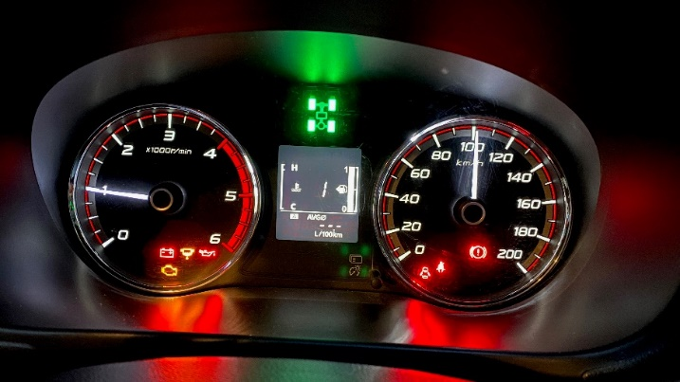  Parameter #  value
- Minimum gear  Default is 2nd  Valid range is 10 to 50 = (1st to 5th).  Use plus (+) and minus (-) to adjust.  NOTE: The transmission from factory does not lockup in 1st gear.  Do not use 1st unless you have an after-market valve body fitted with the 1st gear lockup modification; otherwise it has no effect. | 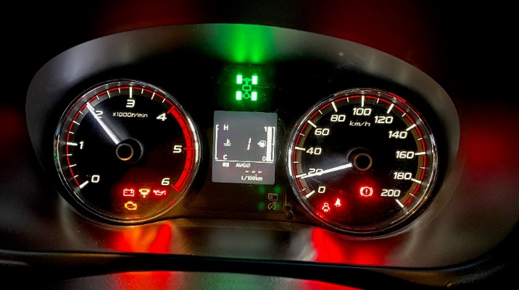
- LED brightness  The LED brightness is displayed, and the LED intensity is adjusted to the current value.  Use plus (+) and minus (-) to adjust.  Use the headlights switch to toggle between night-time brightness and daytime brightness.  Night-time brightness is best adjusted when it’s dark. | 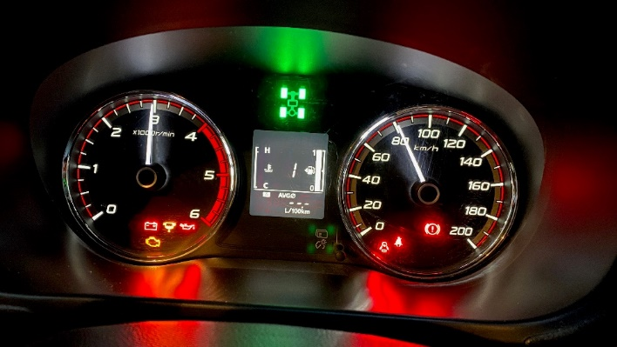
- Warmup Temperature
The minimum temperature before lockup-mate activates. The temperature is displayed on the speedo. 40kph = 40 ºC.
Use plus (+) and minus (-) to adjust.
The allowable range is between 20ºC to 100ºC
The default is 40ºC.
- DRIVE Activation speed  When in DRIVE mode it will only activate lockup above this speed. [default is 75 kph]  The allowable range is between 40kph to 120kph  75 kph is the lowest speed for lockup in 5th gear. Lower values are not recommended as they cause unnecessary lock/unlock cycles, as to the transmission ECU usually selects a gear too high to allow lockup. | 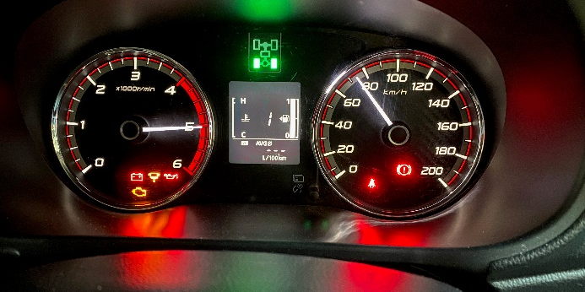

WARRANTY POLICY
MM 4X4 is committed to providing quality products to you and this policy outlines our warranty against defective products manufactured by MM 4X4.
MM 4X4 warrants our manufactured products against defects in workmanship or materials for the Warranty Period. The warranty does not cover damage due to normal wear and tear (for example marks and scratches).
This warranty is not applicable to products re-sold by MM 4X4. Warranties for these products are defined by the manufacturer.
MM 4X4 accepts no liability for damage to the vehicle as a result of product installation or use.
Warranty Period
MM 4X4 warrants MM 4X4 manufactured products for a period of 12 months commencing from the date of purchase.
Warranty Entitlement
To be entitled to claim a warranty claim, the customer must:
- Fit the product according to the provided installations instructions;
- Provide evidence of purchase;
- Return the faulty product to MM 4X4 for assessment against the Warranty Entitlement Exclusions; and
- Make a claim within the Warranty Period.
Warranty Entitlement Exclusions
The Customer is not entitled to a warranty claim if:
- The defect is the result of misuse, inappropriate use, incorrect installation, or installation into a vehicle not supported by the product; or
- The product has been modified; or
- The product housing has been opened; or
- The product has been damaged.
Making a Warranty Claim
To make a warranty claim:
- Contact MM 4X4 (enquiries@mm4x4.com.au) to discuss the claim;
- If directed by MM 4X4, return the product to the address provided by MM 4X4 (at the customer's expense) and ensure the product is accompanied with the following information:
- A copy of the proof of purchase;
- The return merchandise authorisation (RMA) number provided by MM 4X4;
- The customer’s name and contact details;
- A return shipping address.
Upon receipt of the faulty product, MM 4X4 will assess the claim against the Warranty Entitlement and Exclusions.
For valid warranty claims, MM 4X4 will repair or replace the goods and ship them (free of charge) to the provided shipping address.
For warranty claims that are assessed as invalid, MM 4X4 will contact the customer to seek further direction, which may include:
- Reasons for denying the warranty claim;
- A quote to repair the fault product;
- Returning the faulty or repaired product to the provided shipping address (at the customer's expense);
- Agreement to dispose of the faulty product; or
- A quote to supply a replacement product.
Warranty Complaints and Enquiries
Our goods come with guarantees that cannot be excluded under the Australian Consumer Law. You are entitled to a replacement or refund for a major failure and compensation for any other reasonably foreseeable loss or damage. You are also entitled to have the goods repaired or replaced if the goods fail to be of acceptable quality and the failure does not amount to a major failure.

ABN 95 625 092 091
Tea Tree Gully, South Australia
Online Shop mm4x4.com.au Email enquiries@mm4x4.com.au

